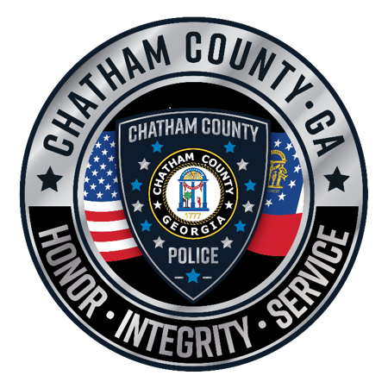

Chatham County Police Department
School Zone Speed Camera Enforcement
Monthly Report
March 2024

Total Citations Issued: 3,477

